3rd Grade

Enrichment Packet
Twin Oaks Elementary 2020

Name_________________________

Math Enrichment
Answer the following questions by shading in the correct response. Show your work for each problem.
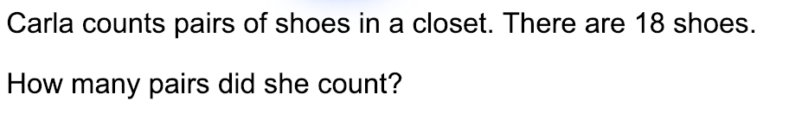

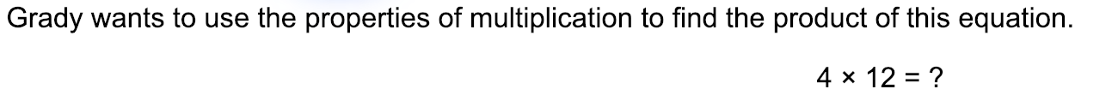
2.
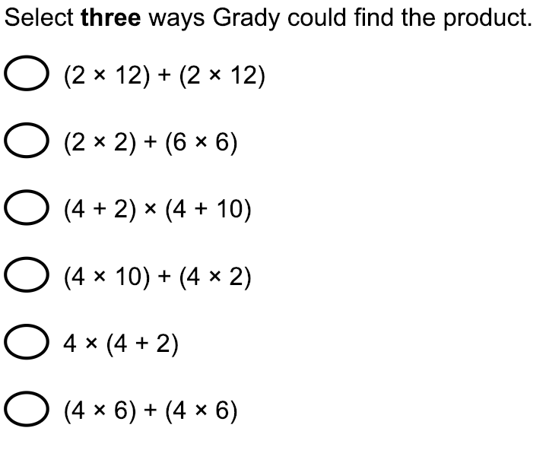

3.

Enter your answer in the box.

4.

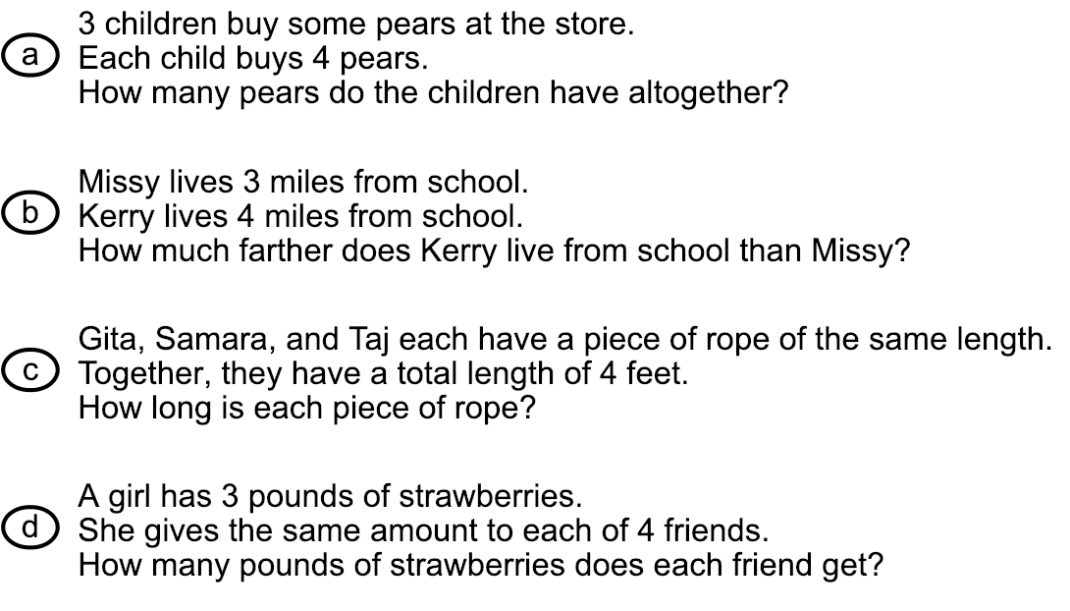
5. Kiara’s birthday celebration started at 2:00 p.m. She spent 46 minutes at the trampoline park. Eating cake and opening presents took 29 minutes. She went back to the trampoline park for 25 more minutes. Using the number line, calculate the time Kiara’s birthday celebration ended to the nearest quarter hour.
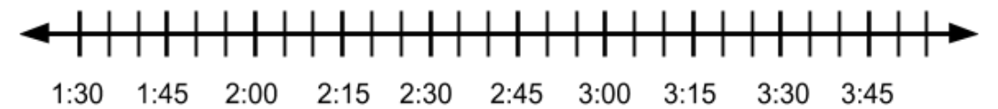
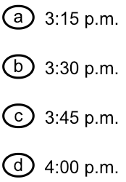

6. Brady bought 27 feet of rope and cut the rope into 3
equal pieces. How many feet long is each piece of rope?
Enter your response in the box.

7.
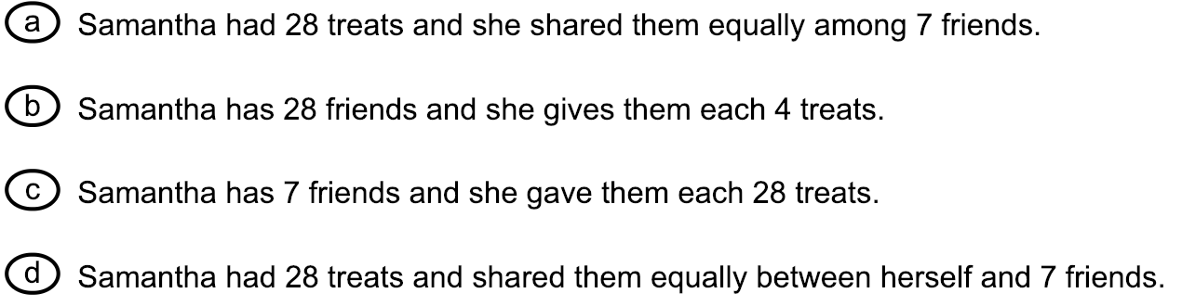

8. Mr. Council plans on using red, green, blue, and yellow tape to create learning centers in his classroom. Each roll of tape has a different length.

- The red tape is 55 feet long.
- The green tape is 25 feet long.
- The blue tape is 15 feet long.

Mr. Council needs a total of 110 feet of tape to create the learning centers in his room.
- Write an equation or equations to show how much yellow tape Mr. Council needs to create the centers.
- What is the total length of yellow tape needed to complete the task?
- Show your work or provide an explanation of the process you used.

Enter your equation or equations, the length of the yellow tape, and your work or explanation in the box below.

9. King runs 6 miles a day. His goal is to run 42 miles. King reasons that after running 5 days, he has run 32 miles. Therefore, he only has to run 10 more miles to reach his goal.

- Explain why King is incorrect in his reasoning.
- Explain how King could correct his reasoning.
- Find the correct number of miles King needs to run to reach his goal.

Enter your answer and your explanation in the box below.

10. Use the fraction model below to help you select the correct symbol to complete the comparison ½ ? ¼ .

11.

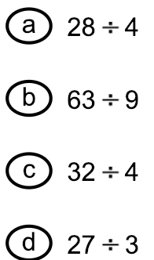

12. Oriana talked to her friend, Harley, on the telephone. The point on the line represents when the phone call begin.
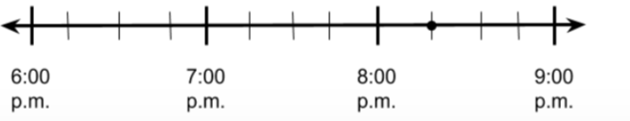

Part A
Orianna began reading her book 45 minutes before she called Harley. At what time did Orianna begin reading reading her book? Use the number line to help explain your thinking.

Part B
Harley went to bed 30 minutes after her phone call with Orianna began. At what time did Harley go to bed? Use the number line to explain your thinking.

Enter your answer and your explanations in the box below.

ELA ENRICHMENT

Today you will read a passage about the Tohono O’odham Indians making jam from cactus fruit. You will then answer several questions based on the passage. Read the passage and question. Then follow the directions to answer each question.

Cactus Jam
by Ruth J. Luhrs

1 Once a year, the Tohono O’odham Indians make jam from cactus fruit. The Tohono O’odham live in the Arizona desert, where the giant saguaro cactus grows.

2 In July, when the fruit is ripe, it splits open to show its bright red insides. Everyone gets ready to help make the jam.

3 Young women use long poles to knock the fruit down. A saguaro can be up to sixty feet tall, and its fruit grows at the top of the cactus and at the ends of its big arms.

4 Children try to catch the fruit in baskets as it falls. Plop, plop! The juicy red fruit is the same size and shape as a hen’s egg. It is full of tiny black seeds.

5 While the young women and children gather the fruit, the men make a camp. They build a shelter to protect everyone from the hot sun. Then they gather wood and light the fires.

6 The children bring their baskets of fruit to the shelter. There, the older women scrape the fruit out of its peel and put it into big cooking pots. They cook it over the fire for a long time. Then they pour the juice through a wire strainer to take out the seeds.

7 Now, the juice must be cooked some more. When it is thick and sweet, the women pour it into clay jars to cool.

8 Finally the jam is ready, and it’s time to feast. The people dance and sing. Children spread the cactus jam on bread and eat all they can hold.

Reprinted by permission of LADYBUG magazine,
February 2000, Vol. 10, No. 6, text copyright, © 2000 by Ruth J. Luhrs

QUESTIONS

- What is the difference between what young women do to make jam and what older women do to make jam?
- Young women help gather the cactus fruit; older women cook the fruit.
- Young women climb the cactus for the fruit; older women catch it below.
- Young women help gather wood for the fires; older women build the fires.
- Young women cook the fruit; older women spread it on bread to eat.

- The passage shows that the process of making jam requires different tools. Each tool has a special purpose in the process. Next to the name of each tool below, in the column labeled “Purpose,” write the correct purpose from the “List of Possible Purposes.” Each tool should have only one purpose, and not all possible purposes will be used.

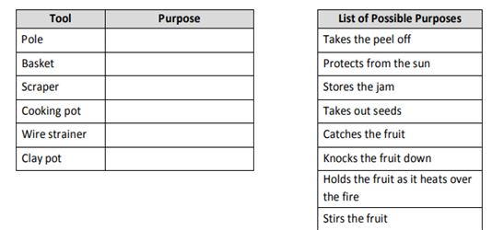

3. This question has two parts. First answer Part A and then answer Part B.

Part A: Why do the young women use poles that are long?
A. to avoid getting too near the tall cactus plants
B. to be able to reach the fruit high in the air
C. to keep the children safe as they receive the fruit
D. to stay out of the way of the fruit when it drops down

Part B: Which sentence from the passage tells the best reason for the correct answer in Part A?
- The Tohono O’odham live in the Arizona desert, where the giant saguaro cactus grows.”
- “Everyone gets ready to help make jam.”
- “A saguaro can be up to sixty feet tall, and its fruit grows at the top of the cactus and at the end of its big arms.”
- “Children try to catch the fruit in baskets as it falls.”

4. The following question has two parts. Answer Part A and then answer Part B.

Part A: What are the steps for making jam? Write each step in the correct box to show the order of the steps for making jam.
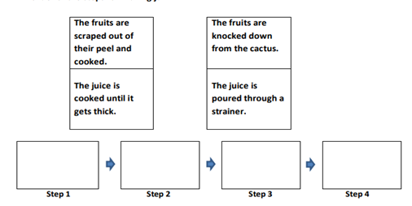

Part B: What has to happen before Step 1 can start?
A. The children have to take their baskets of fruit to the shelter.
B. The fruit has to ripen and split open.
C. The women have to take the seeds out of the fruit.
D. The men have to build the fires for cooking.

6. The following question has two parts. Answer Part A and then answer Part B.

Part A: What is one of the main ideas in the passage?
A. Groups of Tohono O’odham make jam by doing different jobs and working together.
B. The Tohono O’odham make food from different plants they find in the desert.
C. Groups of Tohono O’odham enjoy working outside in the summer.
D. The Tohono O’odham enjoy having a special sweet treat at the end of a busy day.

Part B: Which three details from the passage best support the main idea in Part A?
A. The Tohono O’odham live in the Arizona desert.
B. The saguaro fruit grows at the top of the cactus and at the ends of its arms.
C. The young women and children gather the fruit from the cactus plants.
D. The men make a shelter and build fires for cooking.
E. The older women scrape the fruit out of its peel, cook it, and strain it.
F. The more it cooks, the thicker and sweeter the jam gets.
G. When the jam is ready, children spread it on bread and eat all they can.

(Optional Writing Prompt) Pretend that you are a member of the Tohono O’odham and live in the Arizona desert. Write a story about the day you helped make jam from the fruits of the saguaro. Start your story when you woke up in the morning and finish your story when you went to bed at night. Use information from the passage in your story, but you may make up details also.

Use the lines on the next page to write your story.

Your writing will be scored on how well you:
- show that you understood the ideas in the passage.
- use ideas from the passage as part of your own story.
- use words and sentences to create images for the reader.
- use periods, capital letters, and correct grammar.

Social Studies Enrichment
Read and study the sources about La Balise. Then use the four sources and your knowledge of social studies to answer the questions.

Source 1
Source 2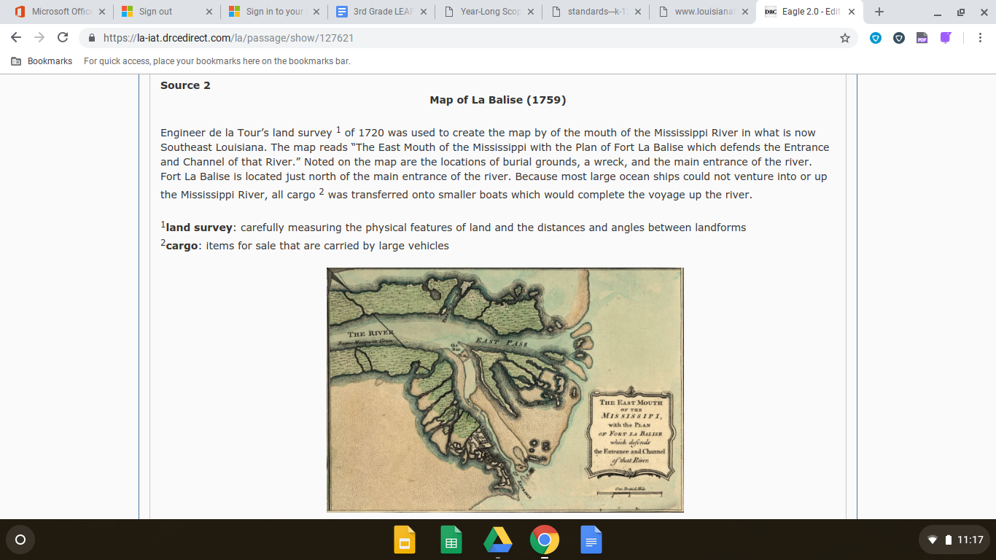

Source 3
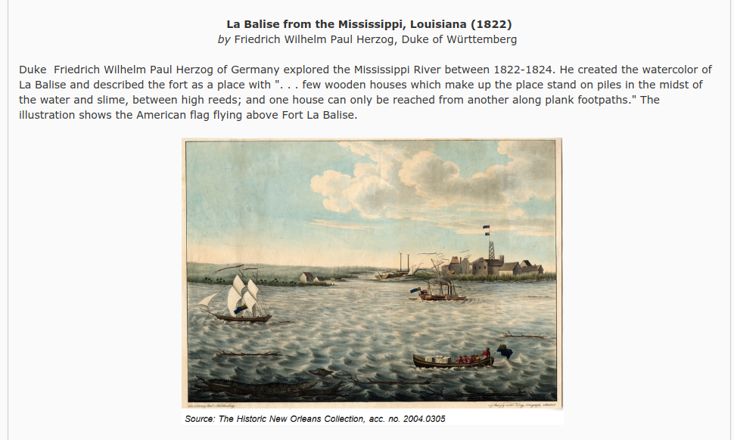

SOURCE 4

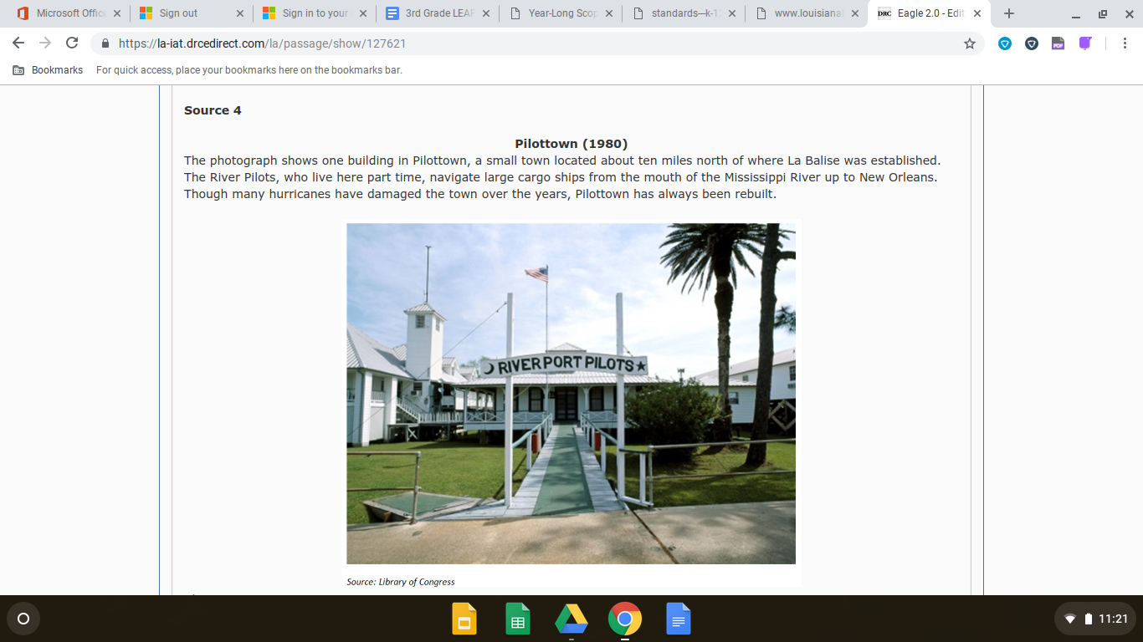

- Which most likely made adapting to life in La Balise difficult?
Select the three correct answers.
  - Hurricanes
  - Fish
  - Floods
  - Alligators
  - Crawfish
  - Rainstorms

- Using the map in Source 2, what is the name of the body of water that the Mississippi River flows into?
  - Gulf of Mexico
  - Atlantic Ocean
  - Lake Pontchartrain
  - Red River

- What type of land is described in Source 3?
  - Prairie
  - Swamp
  - Marsh
  - Valley

- Which natural feature was most important to the early Spanish and French explorers as shown in the map in Source 2?
  - Toulouse
  - Mississippi River
  - East Pass
  - Pass a Sauvol

- Using Source 3 and Source 4, what does the “plank footpath” and buildings “on piles” tell about the land?
  - The land often flooded
  - The land had many alligators
  - The land was uneven
  - The land contained thick forests.

- Why did the early explorers concentrate on the area shown in Source 2?
  - The location was within a few days travel to their vast empires in South America.
  - The New World was filled with gold and valuable other treasures that were readily taken from the waterways.
  - The animal skins that were found in the region were in high demand in Spain.
  - The Mississippi River was a valuable natural resource that could benefit their economic plans.
- What is the significance of La Salle’s land claim in 1682 as shown in Source 1?
  - He was the first European to gain access to the New World.
  - His land claim allowed France to control vast territory in the New World.
  - He was able to establish trading posts between Native Americans and Britain.
  - His land claim gave King Louis XIV complete control in the New World.

- What is the most likely reason that de la Tour’s land survey was used to create the map shown in Source 2?
  - The map helped to find the shortest route from the Gulf of Mexico to New Orleans.
  - The map would safely navigate ships in the waterways of northern Louisiana.
  - The map helped in the development and settlement of New Orleans and surrounding regions.
  - The map marked the locations of any Native Americans living in the region.

- Why did the United States purchase the Louisiana Territory from the French?
  - To increase the amount of citizens that would be able to pay taxes for government services.
  - To secure the natural resources found in the area.
  - To create a boundary between the colonies and Native Americans out west.
  - To expand territory and control the trade along the Mississippi River.

Source 1

Source 2

Throughout our state, there are festivals that celebrate elements of our culture. Different festivals celebrate holidays, music, food, and other aspects of our culture. This 1984 painting by Cajun artist George Rodrigue was done for the Breaux Bridge Crawfish Festival. The festival, beginning in 1960, helped to build local interest in shellfish. Today, the festival brings in thousands of people over three days. People come to listen to over thirty bands that play Cajun, Zydeco, and even Swamp Pop. Other activities include a dance contest, crawfish eating contest, crawfish races, and cook offs.

10. Using Source 1 and Source 2 from above and based on what you know about the mixture of traditions and culture found in Louisiana, describe two specific reasons people would want to visit Louisiana.

______________________________________________________________________________________________________________________________________________________________________________________________________________________________________________________________________________________________________________________________________________________________________________________________________
______________________________________________________________________________________________________________________________________________________________________________________________________________________________________________________________________________________________________________________________________________________________________________________________________
______________________________________________________________________________________________________________________________________________________________________________________________________________________________________________________________________________________________________________________________________________________________________________________________________
______________________________________________________________________________________________________________________________________________________________________________________________________________________________________________________________________________________________________________________________________________________________________________________________________
______________________________________________________________________________________________________________________________________________________________________________________________________________________________________________________________________________________________________________________________________________________________________________________________________

Use the information about Oil Spills in the ocean and your knowledge of science to answer question 1.

1)
Ships called tankers carry oil across the ocean. Accidents and engineering failures can cause the oil in the tankers to spill into the ocean. Oil spills harm plants and animals that live in the ocean. Scientists and engineers find ways to collect some of the oil to remove it from the environment.

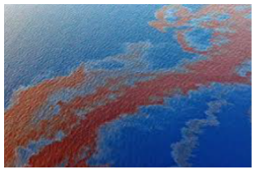
Oil spill in the ocean
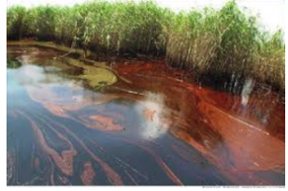
Oil spill by the shore
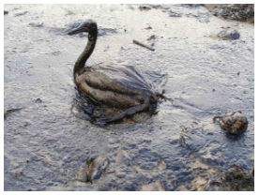
Bird covered in oil

Dr. Warner is a scientist who conducts an experiment. Dr. Warner places black powder on the oil and tests to see if a magnet will pull the black powder and oil to the side of the tub. The steps in Dr. Warner’s experiment are listed below:

- Places water in a large plastic tub
- Pours oil into the water
- Drops black powder on the oil
- Places a large magnet on the side of the plastic tub

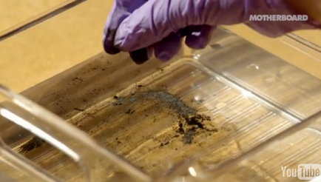
Dr. Warner dropping black powder on the oil.
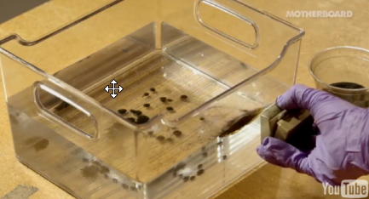
Dr. Warner holding the magnet next to the tub.

a) Which scientific question might Dr. Warner answer using this experiment?

a.How will plant life be affected by the oil in the ocean?
b.How can magnets be used to move oil in water?
c.How can tankers stop spilling oil into the oceans?
d.How will animal life be affected by the oil in the ocean?

b)
Students in a 3rd grade classroom did a similar experiment using four different materials. During the experiment, the students place oil in a square container and test the materials to determine if they will collect oil from the surface of the water in the container. They use black powder and magnets like Dr. Warner did. They also use feathers, sponges, and paper towels to collect the oil from the surface of the water. The data are shown in the chart below:

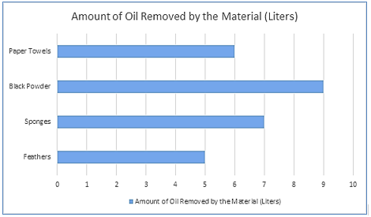

Based on the data from the graph, what can you conclude?

- The black powder collected more oil from the surface of the water than the paper towels and the feathers.
- The sponges collected more oil from the surface of the water than the feathers and the black powder.
- The paper towels and the feathers each collected more oil from the surface of the water than the sponges
- The sponges collected the most oil from the surface of the water out of all four materials.

c.)
How was the magnet able to move the black powder when the magnet was outside of the tub?
- Magnets can attract liquids such as water.
- Magnets can attract liquids such as oil.
- There is a magnet on the other side of the tub.
- Magnets can attract a substance in the black powder.

d)
Will the black powder harm the plants that live in the ecosystem? Design a process that the students can follow to test the question in their classroom.

Enter your process in the box below.

2)
Burmese pythons, one of the largest snake species on earth, are originally from Southeast Asia. These snakes are long and thick. They can grow to be 20 feet long, which is as tall as an adult giraffe, and can weigh as much as a fully grown man. Burmese pythons have an incredible sense of smell, are good climbers, are not poisonous and can use their tails to wrap around things. Their diet consists mainly of small animals, birds, reptiles, and frogs. The heat sensors along their upper lips help them find food and their jaws stretch far apart, which allow them to swallow animals with bodies much larger than their own head. They squeeze their prey with their bodies and swallow them whole.

In recent years, Burmese pythons have begun breeding in the Everglades National Park and spreading throughout south Florida. They are found mainly in marshes, swamps, and jungle habitats in the Everglades area. Residents that live around the Everglades National Park have complained to the city council about the increasing numbers of pythons in the area.

Graph 1: Burmese Pythons Found in the Everglades National Park
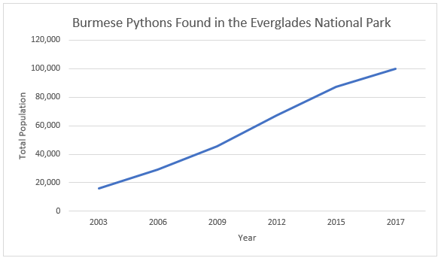
The city council hired a team to come up with a plan to reduce the number of pythons in the park.
As a result, the team developed a plan to capture and remove the pythons from the park.

Graph 2: Burmese Pythons Removed from the Everglades National Park
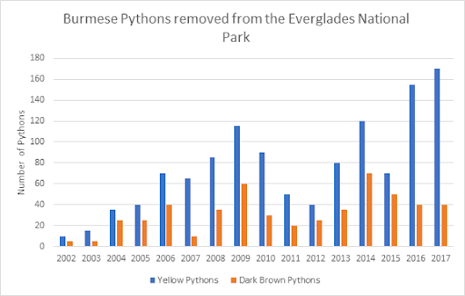
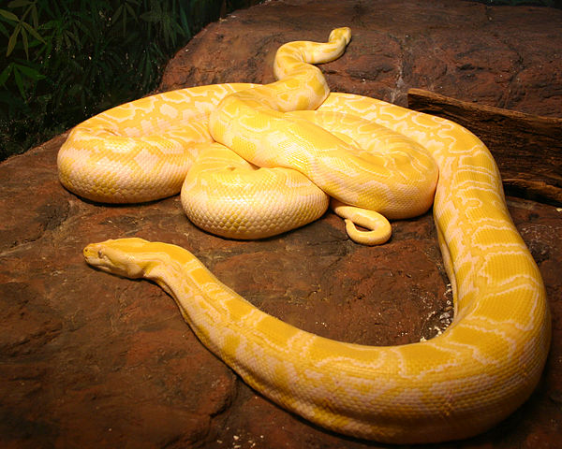

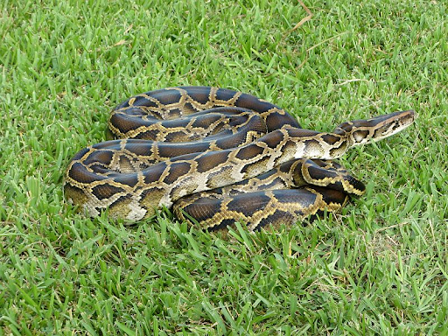

PART A
Using Graph 2, what can you conclude about the Burmese python populations in the Everglades National Park?

- The same number of brown and yellow pythons were removed from the Everglades.
- More yellow pythons have been removed from the Everglades than brown pythons.
- There was a decline in the number of yellow pythons being removed from the Everglades.
- The number of brown pythons removed from the Everglades was double that of the yellow pythons.

PART B
What is a reasonable explanation for the change that occurred with the python populations in the Everglades National Park?

- The yellow and brown pythons inherited the same favorable physical characteristics from their parents.
- The yellow pythons inherited less favorable physical characteristics from their parents than the brown pythons.
- The yellow pythons inherited more favorable physical characteristics from their parents than the brown pythons.
- The brown pythons inherited less favorable physical characteristics from their parents than the brown pythons.

b)
Explain the most likely reason why the number of yellow and brown python populations that are captured in the Everglades National Park are different?

- Yellow pythons are more popular than dark brown pythons.
- Dark brown pythons camouflage better than yellow pythons.
- Yellow pythons have a longer lifespan than dark brown pythons.
- Dark brown pythons have a longer lifespan than yellow pythons.

c)
Which of the python’s traits are influenced by the environment?

- Pythons can stretch their jaws.
- Pythons are good climbers.
- Pythons are found in marshes.
- Pythons grow to 20 feet.

d)
Why does the population of Burmese pythons continue to increase in the Everglades?

- There are a sparse amount of trees for them to live in.
- There are no natural predators hunting the Burmese pythons.
- There are no efforts to try and limit the population.
- There is a cold climate in the Everglades.

e)
What is an effect of the increased population of the pythons?

- The presence of the Burmese python in the Florida Everglades has caused many Florida residents to create python habitat restoration homes.
- The presence of the Burmese python in the Florida Everglades has caused the population of Southeast Asian Burmese pythons to decline.
- The presence of the Burmese python in the Florida Everglades has continued to increase over time causing many people to worry.
- The presence of the Burmese python has caused the alligator population to grow due to the increasing amounts of pythons in the south.

f)
Due to the increase of the Burmese pythons in the Everglades National Park, the park decides to build a fence around the outside of the park. The city council does not think this will reduce the python population. Write a claim to support the city council’s opinion and explain your answer.

Enter your claim and explanation in the box below.

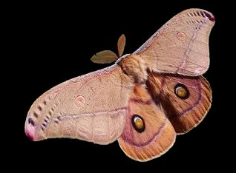

3) Dark-colored and light-colored moths live in England. In the mid-1800s, the percentage of dark-colored moths increased in areas where black soot (a powdery substance) from factories covered the trees where the moths lived.

a)
Which of the following best explains what caused the population of dark-colored moths to increase?
- The dark-colored moths found a better food source and more of them survived to reproduce.
- The dark-colored moths began having more offspring each time they reproduced.
- The dark-colored moths were smarter and more of them survived to reproduce.
- The dark-colored moths were better camouflaged and more of them survived to reproduce.

4)
A group of students are interested in conducting an experiment using a Newton’s cradle. The students are instructed to make a prediction supported by evidence about what will happen when they lift one ball and let it go.

a)
Which predictions best explain what will occur when an unbalanced force is applied to the cradle? Select the two best answers.

- When an unbalanced force is applied to the cradle, the second metal ball will move first.
- When an unbalanced force is applied to the cradle, the second metal ball will not move.
- When an unbalanced force is applied to the cradle, the forces acting on the second metal ball is equal to zero.
- When an unbalanced force is applied to the cradle, the forces acting on the second metal ball is not equal to zero.
- When an unbalanced force is applied to the cradle, the strength of the forces remain the same.

5)
While at the park, Brandon bounces a soccer ball up and down and his friend Josh plays with a basketball. The boys decide to set up an experiment to determine if the bounce height of the soccer and basketball will change if the balls are bounced on a soccer field or basketball court. The boys drop the balls from the same height and measure the bounce height of the balls when they hit the soccer field and basketball court. The results of their experiment are below.

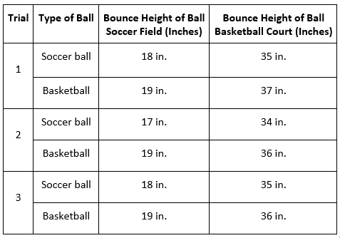

a)
Based on the patterns in the data, how might the bounce height of the balls change if Josh and Brandon completed the same experiment on a football field?

- The balls will bounce higher than they did on the soccer field and basketball court.
- The balls will bounce about the same as they did on the soccer field.
- The balls will bounce about the same as they did on the basketball court.
- The balls will not bounce as high as they did on the soccer field and basketball court.

6)
A class of students research the annual temperatures of four major biomes. The students share the information they gather on the tundra, tropical rainforest, desert, and grasslands biomes in the charts below.
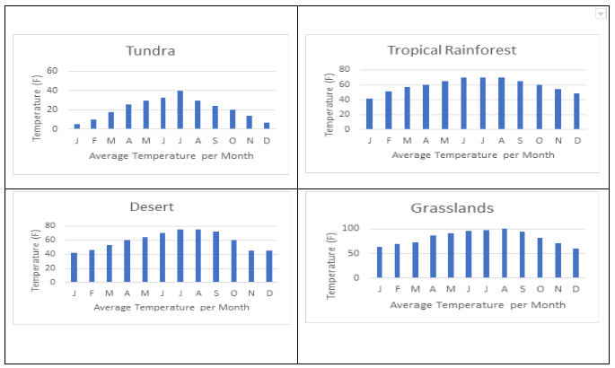

a)
Which of the following explains a similar climate to that of the tropical rainforest?
- The tropical rainforest and deserts have similar yearly temperatures.
- The grasslands have a cooler climate during the summer months than the tundra.
- The tundra biome and the tropical rainforest biome receive direct sunlight.
- The tropical rainforest and desert have consistent types of temperatures during the day and night.

7)
The Jones family wants to take a vacation to New Orleans, Louisiana and Boston, Massachusetts. As the seasons change, they track the average temperatures and average rainfalls of the cities.

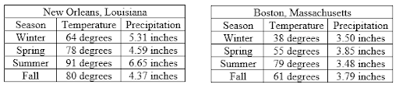

a)
The Jones family will be planning a trip in the upcoming year and wondered which graph would be an accurate prediction of the average temperatures in New Orleans and Boston?

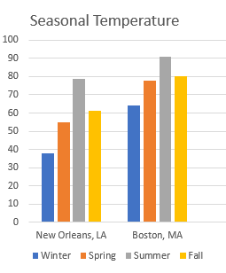

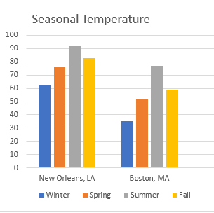

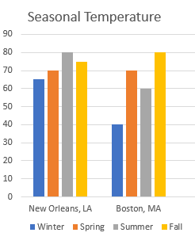

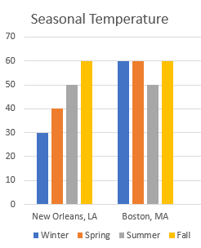

8)
There are many different types of birds that live near or along the Gulf of Mexico. Below are four types of birds that are commonly found in the area.
These birds have different physical characteristics and features.
*Wading birds-walk through water in search of food

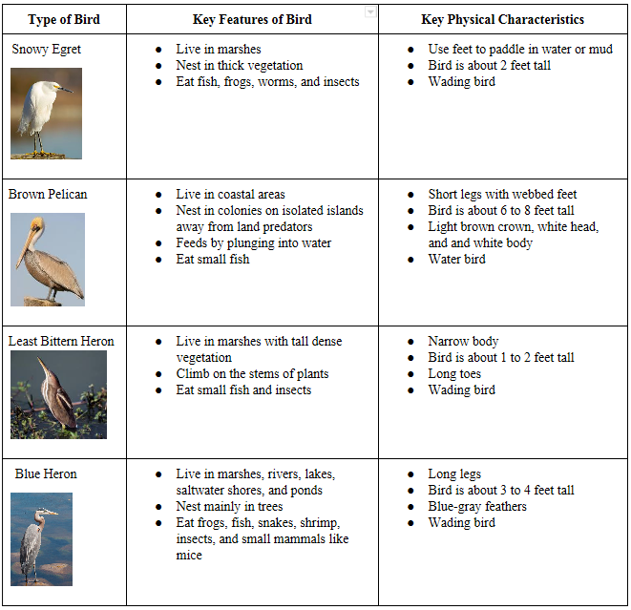

a)
In 2010, the Deepwater Horizon oil spill released about 4.9 million barrels of oil into the Gulf of Mexico. The oil spill harmed birds and habitats along the Gulf of Mexico.

Part A

Which bird would be best suited for the change happening in the Gulf of Mexico?
- Snowy Egret
- Brown Pelican
- Least Bittern Heron
- Blue Heron

Part B
Why would the bird be best suited for the change happening in the Gulf of Mexico?

- Snowy Egrets are camouflaged in the marsh.
- Brown Pelicans plunge into the water to feed.
- Least Bitterns are losing vegetation to stand on.
- Blue herons nest mainly in trees.

9)
Drainage in New Orleans, Louisiana, has been a major concern since the city was founded in the early 18th century, remaining an important factor in the history of New Orleans today. The center of New Orleans is almost completely surrounded by water. Much of this land area is at or below sea level, and it no longer has a natural outlet for flowing water. This means that all rainfall occurring within this area must be removed through pumping. Thus, flood threats to New Orleans include the Mississippi River, Lake Pontchartrain, and natural rainfall. Man-made levees have been built to keep out rising river and lake waters but have had the negative effect of keeping rainfall in. This is a levee preventing the water from the Mississippi River to flood a part of New Orleans, Louisiana.
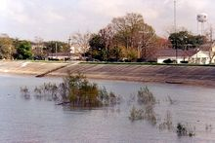

a)
Which of the following methods will reduce the drainage problems in the city?

- Building more houses/buildings along the levee
- Constructing larger levee walls
- Removing large trees
- Installing a pumping system

10)
Jack’s grandfather collected fossils his whole life. One day Jack’s grandfather was telling him that he found a fossil of a leaf while visiting the desert. Jack knew that leafy plants do not live in a desert so he was not sure how a leaf fossil could be found in the desert.

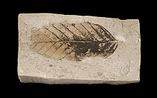

Which of the following statements best explains how a leaf fossil would be discovered in the desert?

- The desert had a water source at one time.
- Leafy plants could once live without water.
- Leafy plants grow well in the desert.
- The leaf was buried in the desert by an explorer.

